Year 11 Revision Booklet

Paper 2: Challenges in the human environment
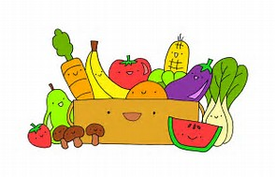
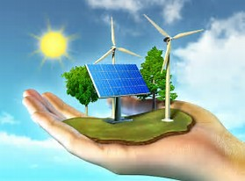
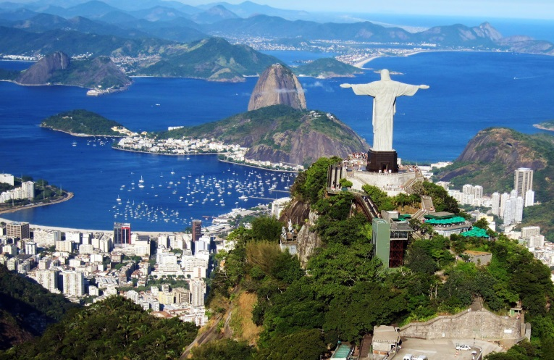
- Urban issues and challenges – Question 1
- The changing economic world – Question 2
- The challenge of resource management – Question 3
- Food – Question 4
- IGNORE QUESTIONS 5 AND 6!

Urban Issues and Challenges – Q1

A growing percentage of the world’s population lives in urban areas
What is urbanisation?
__________________________________________________________________________________________________________________________________________
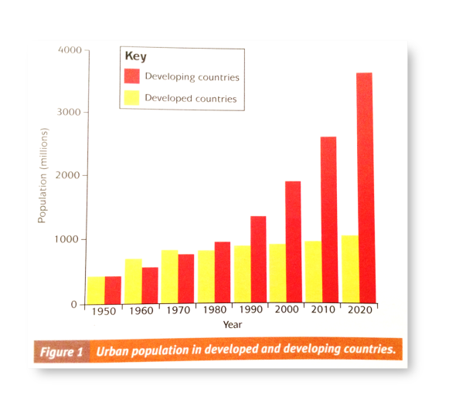
Describe the changes to the urban population in developed (HIC) and developing (LIC) countries.
________________________________________________________________________________________________________________________________________________________________________________________________________________________________________________________________________________________________________________________________________________________________________________________________________________________________________________________________________________________________________________________________________________________________________________________________________________________________

Why is urbanisation happening at a faster rate in LICs and a slower rate in HICs?
_________________________________________________________________________________________________________________________________________________________________________________________________________________________________________________________________________________________________________________________________________________________
Outline the factors below to explain how they affect the rate of urbanisation:
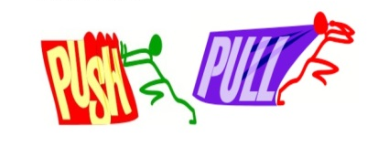
- Migration (push and pull factors): ____________________ ________________________________________________________________________________________________
- Natural increase: ________________________________ ________________________________________________________________________________________________

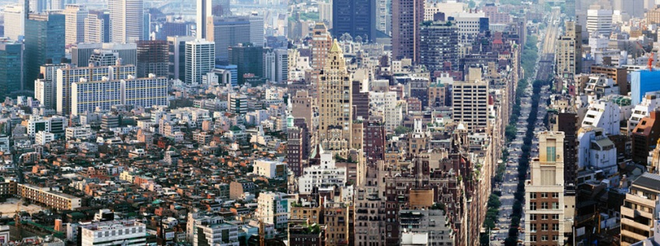
What is a megacity?
_____________________________________________________________________________________________

What is rural-urban migration?
__________________________________________________________________________________________________________________________________________
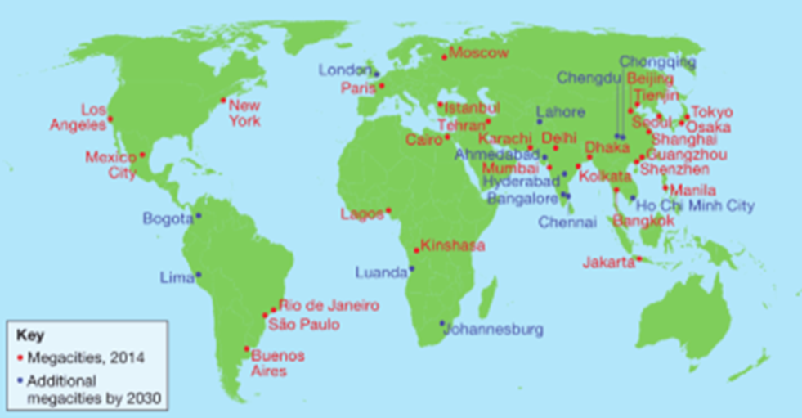
Describe the distribution of the world’s megacities.
____________________________________________________________________________________________________________________________________________________________________________________________________________________________________________________________________________________________________________________________________________________________________________________________________________________________________________________________

Urban growth creates opportunities and challenges for cities in LICs and NEEs
Case study of a major city in a NEE: Rio de Janeiro, Brazil
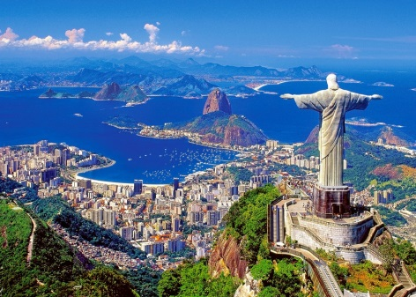
Complete the table to show why Rio de Janeiro is important regionally, nationally and internationally:
Regionally | Nationally | Internationally

Why is Rio a growing city? (Think about natural increase and migration).
_______________________________________________________________________________________________________________________________________________________________________________________________________________
Complete the mind map below to show the social and economic opportunities for people living in Rio:

Access to jobs and money
Access to resources: water supply and electricity
Access to services: health and education
Opportunities

What are the challenges created by urban growth in Rio? Complete the table with brief notes to show these challenges:
Squatter settlements | Clean water, sewage and electricity | Health and education | Unemployment and crime | Waste, pollution and traffic congestion

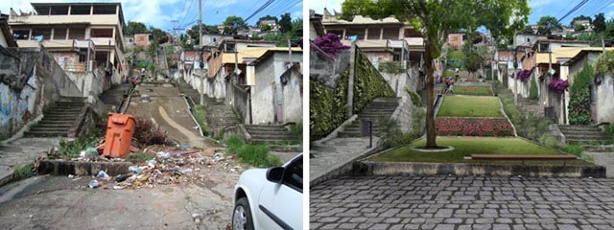
An example of how urban planning is improving the quality of life for the urban poor: Favela Bairro Project, Rio de Janeiro
List 5 improvements that were made by the Favela Bairro Project:
- ____________________________________________________
- _______________________________________________________________
- _______________________________________________________________
- _______________________________________________________________
- _______________________________________________________________
What were the successes and failures of the Favela Bairro Project?
Successes | Failures

Urban change in cities in the UK leads to a variety of social, economic and environmental opportunities and challenges
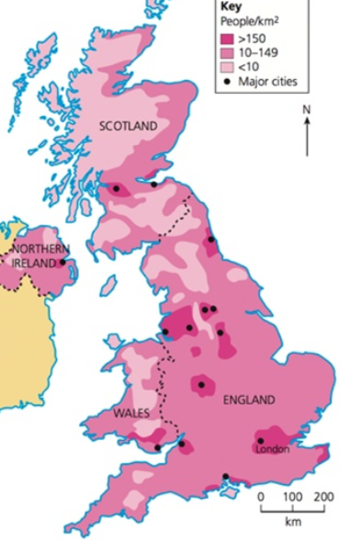
Describe the population distribution in the UK. Include names of cities and compass points in your answer. Include most and least populated areas.
_______________________________________________________________________________________________________________________________________________________________________________________________________________________________________________________________________________________________________________________________________________________________________________________________________________________________________
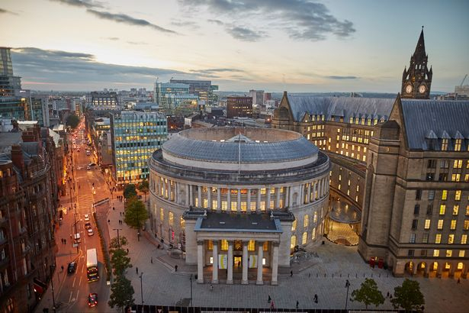
A case study of a major city in the UK: London
List 5 reasons why London is a major city, both in the UK and in the wider world:
- ____________________________________________________________________
- ____________________________________________________________________
- ________________________________________________________________________________________________________________________________
- ________________________________________________________________________________________________________________________________
- ________________________________________________________________________________________________________________________________
How has migration impacted on the growth and character of the city? Think about what you find in London and where the influence might have come from, e.g. Chinatown.
___________________________________________________________________________________________________________________________________________________________________________________________________________________________________________________________________________________________________________________________________________________________________________________________________________________________________________________________________________________________________
Outline the opportunities created by urban change in London in the table below:
Cultural mix | Recreation and entertainment | Employment | Transport systems | Urban greening

Complete annotations below to explain the challenges created by urban change in London.

Environmental dereliction, building on brownfield and greenfield sites, waste disposal
Social and economic: deprivation, inequalities in housing, education, health and employment

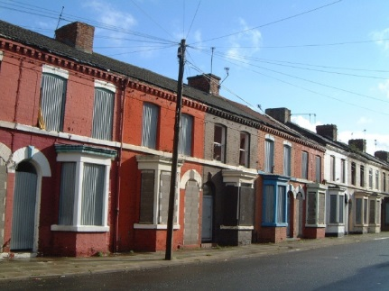

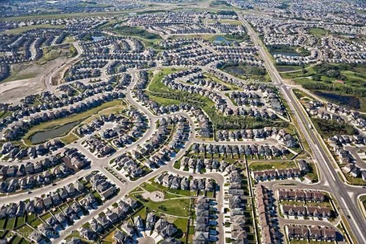

Impact of urban sprawl on the rural-urban fringe and the growth of commuter settlements

An example of an urban regeneration project: Olympic Park
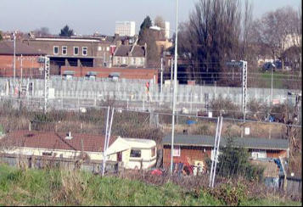
Why did the area need regeneration? Use the images below to help you:
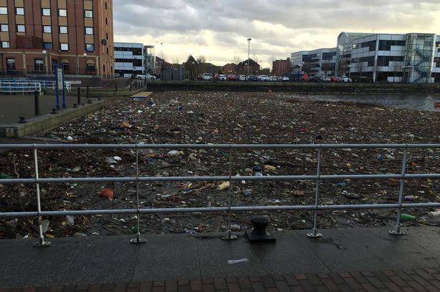
_______________________________________________________________________________________________________________________________________________________________________________________________________________________________________________________________________________________________________________________________________________________________________________________________________________________________________

Complete the table below to show the main features of the project:
Social improvements | Economic improvements | Environmental improvements

Urban sustainability requires management of resources and transport
What is the definition of ‘sustainable urban living’?
__________________________________________________________________________________________________________________________________________
Identify 5 features of a sustainable city:
- ________________________________________________________________
- ________________________________________________________________
- ________________________________________________________________
- ________________________________________________________________
- ________________________________________________________________
Choose 2 from your list above and explain how this characteristic makes a city sustainable:
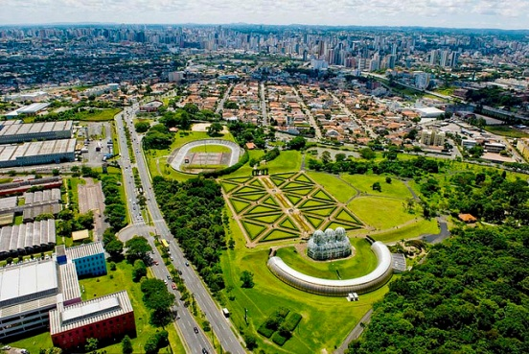
- ________________________________________________________________________________________________________________________________________________________________________________________________
- _____________________________________________________________________________________________________________________________________________________________________________________________________________________________________________________

How urban transport strategies are used to reduce traffic congestion: London
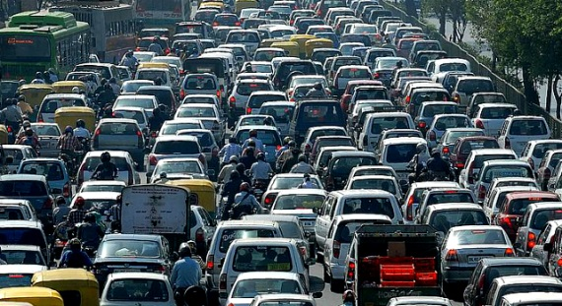
Give 2 reasons why there are more cars on the roads now:
- ______________________________________________________________________________
- ______________________________________________________________________________

Outline what London has done to reduce traffic and the effects of traffic:
Pedestrianisation | Train | Congestion Charge | Bike hire | BedZed

Identify the advantages and disadvantages of the schemes used by London to reduce traffic:
Advantages/successes | Disadvantages/failures

The Changing Economic World – Q2

There are global variations in economic development and quality of life
What is development?
_____________________________________________________________________
The Brandt Line (shown on the map) divides the world into developed and developing countries. Describe the location of the developed and developing countries.
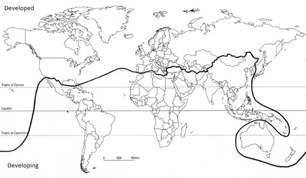
___________________________________________________________________________________________________________________________________________________________________________________________________________________________________________________________________________________________________________________________________________________________________________________________________________________________________________________
List the measures of development that are used to classify countries and give a brief definition. The list has been started for you:
- GNI (Gross National Income) __________________________________________
- HDI (Human Development Index) _______________________________________
- Literacy rate ______________________________________________________
- ________________________________________________________________
- ________________________________________________________________
- ________________________________________________________________
- ________________________________________________________________
What are the limitations of these measures of development? I.e. why can they not be trusted entirely?
______________________________________________________________________________________________________________________________________________________________________________________________________________________________________________________________________________________________________________________________________________________________________________

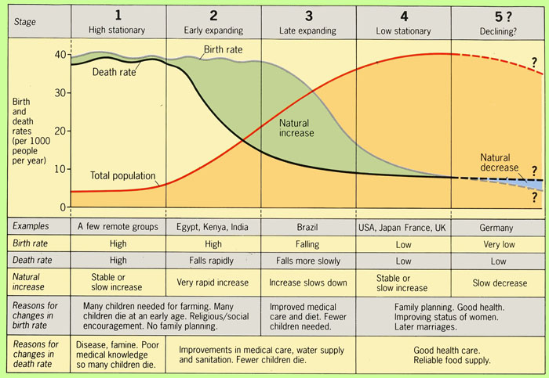
The demographic transition model (DTM) shows changes over time in the population of a country. As a country develops it should move through the stages of the model.
How does a falling birth rate (fewer children) reflect increased economic development?
__________________________________________________________________________________________________________________________________________________________________________________________________________________________________________________________________________________________________________________________________________
How does an increasing death rate reflect high levels of development?
__________________________________________________________________________________________________________________________________________________________________________________________________________________________________________________________________________________________________________________
Briefly outline 5 factors that cause uneven development (there should be at least one physical, one economic and one historical):
- ________________________________________________________________________________________________________________________________________________
- ________________________________________________________________________________________________________________________________________________
- ________________________________________________________________________________________________________________________________
- ________________________________________________________________________________________________________________________________
- ________________________________________________________________________________________________________________________________

What does the word ‘disparity’ mean?
_____________________________________________________________________

Briefly outline how the factors below are caused by uneven development:
Consequence: disparities in wealth | Consequence: disparities in health | Consequence: international migration
 | 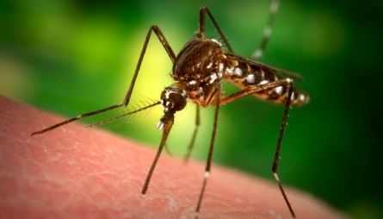 | 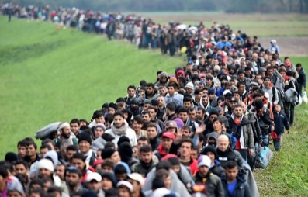

Various strategies exist for reducing the global development gap
What is the development gap?
__________________________________________________________________________________________________________________________________________
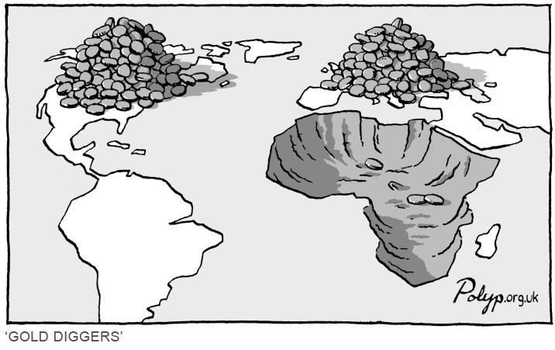
What message does this image show?
___________________________________________________________________________________________________________________________________________________________________________________________________________________________________________________

Complete the table below outlining what each strategy involves and how it will help to improve the development of LICs:
Strategy | What does it involve? | How will this reduce the development gap?
Investment
Industrial development
Tourism
Aid
Intermediate technology
Fairtrade
Debt relief
Microfinance loans

An example of how the growth of tourism in a LIC or NEE helps to reduce the development gap: Tunisia

List 5 attractions that Tunisia has that will attract tourists to the country:
- ________________________________________________________________
- ________________________________________________________________________________________________________________________________
- ________________________________________________________________
- ________________________________________________________________
- ________________________________________________________________

List 5 advantages and 5 disadvantages (be specific) of tourism in Tunisia– how does it help to reduce the development gap, but why is it not entirely perfect?
Advantages | Disadvantages

Some LICs and NEEs are experiencing rapid economic development which leads to significant social, environmental and cultural change
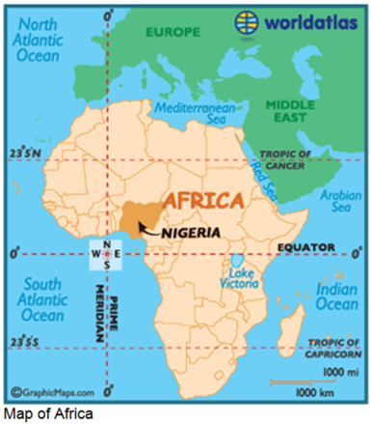
A case study of a NEE: Nigeria, Africa
Describe the location of Nigeria (using geographical terminology).
__________________________________________________________________________________________________________________________________________________________________________________________________________________________________________________________________________________________________________________
Why is it such an important country globally? What does it contribute to the world?
_______________________________________________________________________________________________________________________________________________________________________________________________________________
Why it one of the most important countries in Africa?
_______________________________________________________________________________________________________________________________________________________________________________________________________________

Complete the mind map showing the political, social, cultural and environmental aspects of Nigeria:

POLITICAL
ENVIRONMENTAL
CULTURAL
SOCIAL
Context of Nigeria

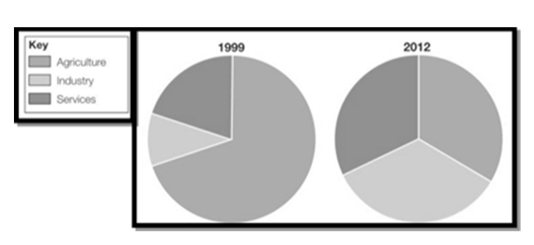
Describe how Nigeria’s economy has changed using the pie charts below:
_____________________________________________________________________________________________________________________________________________________________________________________________________________________________________________________________________________________________________
How does the growth in manufacturing affect Nigeria’s economic development?
_________________________________________________________________________________________________________________________________________________________________________________________________________________________________________________________________________________________________________________________________________________________

What is a TNC?
______________________________________________________________
Why do TNCs like Shell locate in Nigeria?
- ________________________________________________________________
- ________________________________________________________________
- ________________________________________________________________
Complete the table below showing the advantages and disadvantages of TNCs in Nigeria:
Advantages | Disadvantages

How has the presence of Shell Oil in Nigeria stimulated industrial development?
______________________________________________________________________________________________________________________________________________________________________________________________________________________________________________________________________________________________________________________________________________________________________________________________________________________________
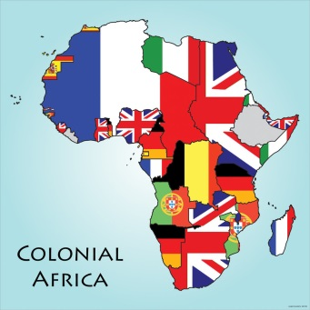
How has Nigeria’s political links with the rest of the world changed since the 1960s when it gained independence?
____________________________________________________________________________________________________________________________________________________________________________________________________________________________________________________________________________________________________________________________________________________________________________________________________________________________________________________________
What does Nigeria contribute in terms of trade to the rest of the world?
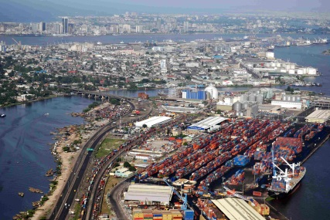
_____________________________________________________________________________________________________________________________________________________________________________________________________________________________________________________
What is aid?
_____________________________________________________________________
When would a country receive emergency aid?
_____________________________________________________________________
When would a country receive developmental aid?
_____________________________________________________________________
Why does Nigeria need aid? Give 3 reasons:
- ________________________________________________________________
- ________________________________________________________________
- ________________________________________________________________
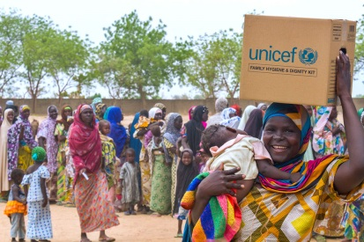
How does aid benefit Nigeria and what prevents this aid being used effectively?

Benefits of aid to Nigeria | Why aid may not be effective in Nigeria

Outline how economic growth can have a negative effect on the environment:

Industrial growth leads to _________________________________________________ _____________________________________________________________________ _____________________________________________________________________
Urban growth leads to ____________________________________________________ __________________________________________________________________________________________________________________________________________
Mining and oil extraction leads to ____________________________________________ __________________________________________________________________________________________________________________________________________
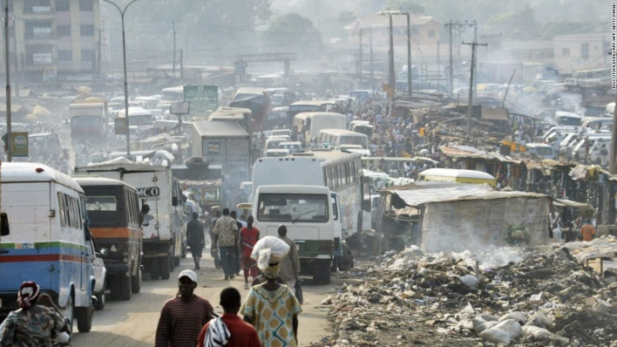
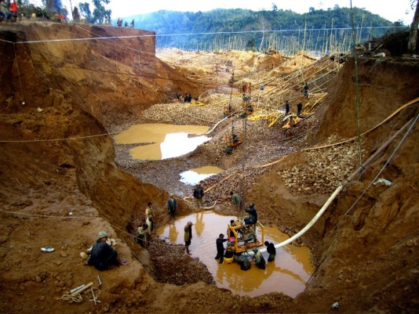

Has people’s quality of life in Nigeria improved as a result of economic development?
Yes it has improved | No it has not improved

Major changes in the economy of the UK have affected, and will continue to affect, employment patterns and regional growth
Outline how the UK’s employment structure has changed since 1800 (i.e. primary, secondary, tertiary and quaternary industries).
_________________________________________________________________________________________________________________________________________________________________________________________________________________________________________________________________________________________________________________________________________________________
Why has it changed in this way? Complete the table below outlining the impact of each factor on the UK economy:
De-industrialisation | Globalisation | Government Policies
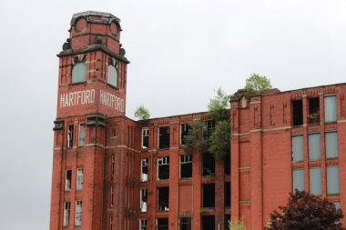 | 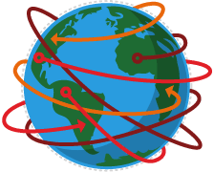 | 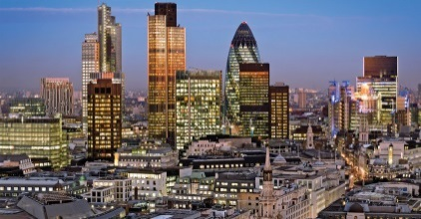

What is a post-industrial economy?
_____________________________________________________________________
How has the development of IT affected the growth and characteristics of the UK’s economy?
___________________________________________________________________________________________________________________________________________________________________________________________________________________________________________________________________________________________________________________________________________________________________________________________________________________________________________________________________________________________________

Outline how service industries, finance and research affect the UK economy:
Service industries and finance | Research

What is a science park?
_____________________________________________________________________
What is a business park?
_____________________________________________________________________
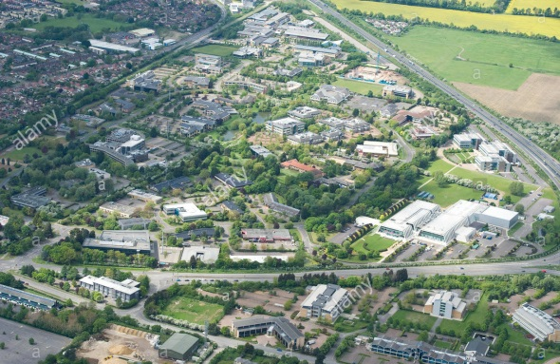
How do science and business parks provide opportunities for regional economic growth?
_____________________________________________________________________________________________________________________________________________________________________________________________________________________________________________________________________________________________________________________________________________________________________________________________________________________________________________________________________________________________________________________
What are the impacts of industry on the physical environment?
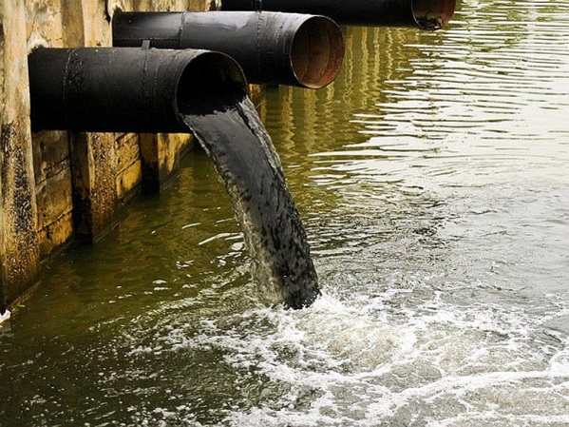
- __________________________________________________________________________
- __________________________________________________________________________
- __________________________________________________________________________
- __________________________________________________________________________

Complete the mind map to show 4 ways in which industrial development can be more sustainable:

Sustainable strategies

An example of how modern industrial development can be more environmentally sustainable: Nissan Car Manufacturers, Sunderland
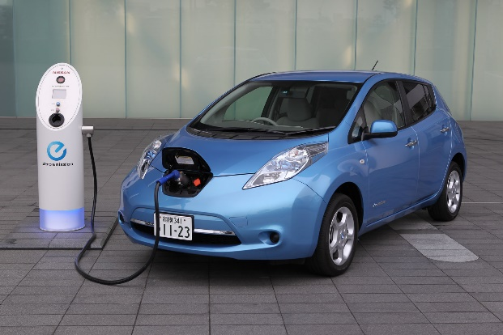
In 2013, Nissan was the sixth largest automaker in the world. Nissan is the world's largest electric vehicle (EV) manufacturer, with global sales of more than 275,000 all-electric vehicles. Nissan have factories in over 20 countries, and their UK factory is based in Sunderland. List below 5 strategies Nissan have done to make their industry more sustainable:
- ________________________________________________________________________________________________________________________________
- ________________________________________________________________________________________________________________________________
- ________________________________________________________________________________________________________________________________
- ________________________________________________________________________________________________________________________________
- ________________________________________________________________________________________________________________________________

Rural landscapes are changing in the UK; some areas are experiencing rapid population growth as people are moving out into the countryside for a more peaceful life, whereas other areas are experiencing population decline.
What are the social and economic impacts of a growing population and a declining population?
 | Social effects | Economic effects
Growing population
Declining population

Improvements to transport infrastructure affect both employment and regional growth. Outline some of the improvements being made to the UK’s transport links:
Type of Transport | Improvements made
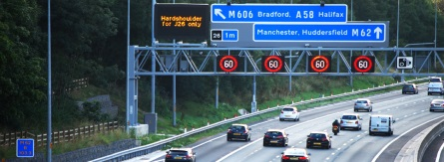
Road improvements
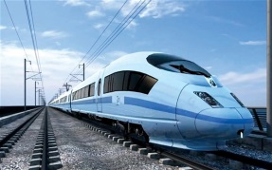
Railway improvements
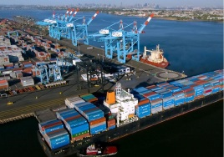
Developing ports
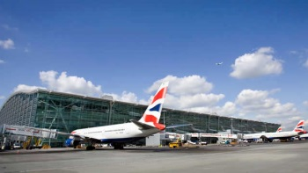
Airport developments

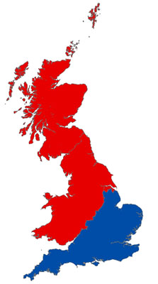
What is the north-south divide?
________________________________________________________
Give 2 reasons why there is a north-south divide:
- ___________________________________________________
___________________________________________________
- ___________________________________________________ ___________________________________________________

List 5 ways in which these regional differences can be resolved (try to give some specific examples of strategies used in the UK):
- ________________________________________________________________
- ________________________________________________________________
- ________________________________________________________________
- ________________________________________________________________
- ________________________________________________________________
How can improved transport links help reduce the north-south divide?
____________________________________________________________________________________________________________________________________________________________________________________________________________________________________________________________________________________
The UK has global links through trade, culture, transport and electronic communications. Briefly outline information for each on the mind map below:

Trade

Electronic communication
Transport
Culture
UK global links

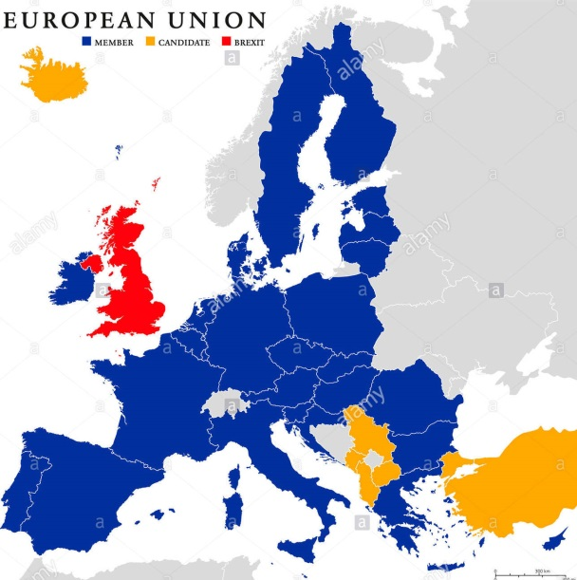
In 1973 the UK became a member of the European Union (EU). It includes 28 countries and has important trading and political influence. In 2016, however, the UK voted to leave the EU and will complete its exit by 2019.
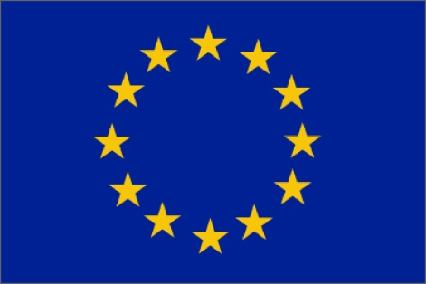

How has the EU affected the UK?
- ________________________________________________________________________________________________________________________________
- ________________________________________________________________________________________________________________________________
- ________________________________________________________________________________________________________________________________

The UK is a member of the Commonwealth which is a voluntary group of 53 countries and 2.2 billion people.
How does the UK benefit from being in the Commonwealth?
- ________________________________________________________________________________________________________________________________
- ________________________________________________________________________________________________________________________________
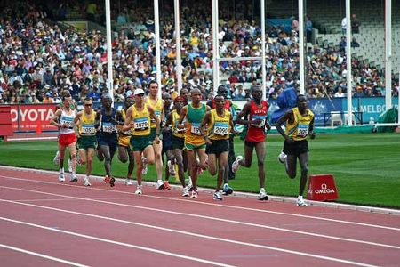

The Challenge of Resource Management – Q3

Food, water and energy are fundamental to human development
What are resources?
_____________________________________________________________________
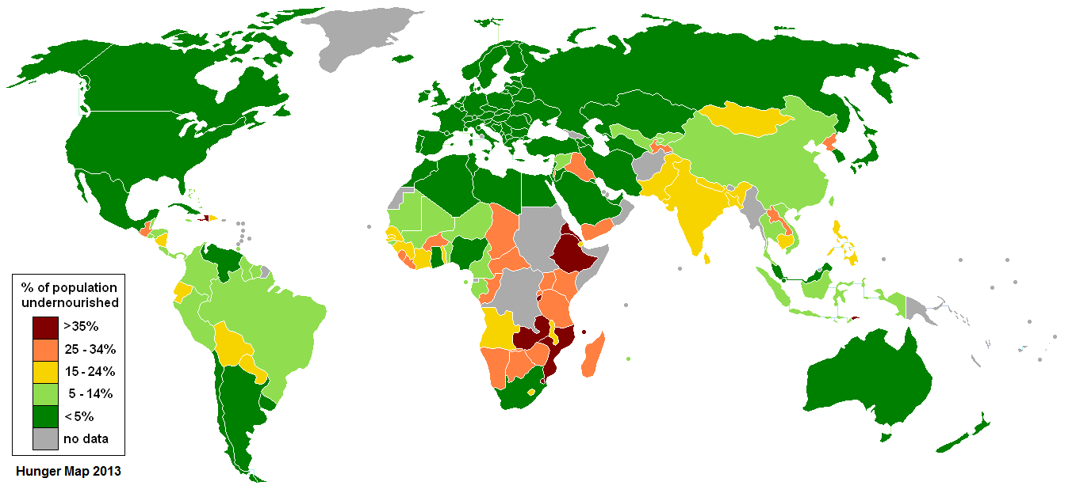
Food
Describe the pattern of global undernourishment.
_________________________________________________________________________________________________________________________________________________________________________________________________________________________________________________________________________________________________________________________________________________________________________________________________________________________________________________________
Why does undernourishment or malnutrition lead to a slowly growing economy?
____________________________________________________________________________________________________________________________________________________________________________________________________________________________________________________________________________________
What is becoming an increasing health issue in HICs linked to food?
____________________________________________________________________
Water
What is meant by physical water scarcity? Give an example of a place that has this.
__________________________________________________________________________________________________________________________________________

What is meant by economic water scarcity? Give an example of a place that has this.
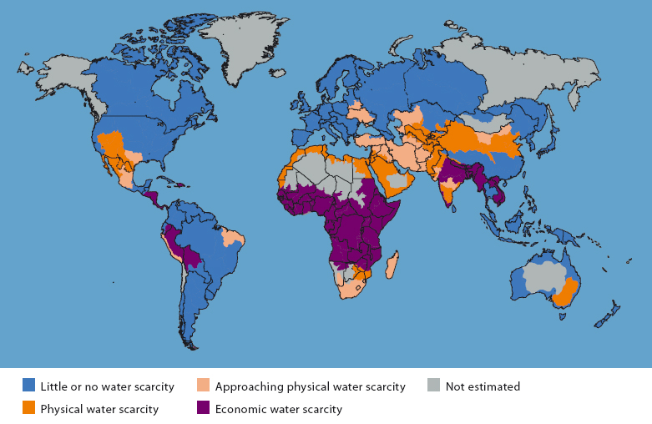
Name 3 continents that have mostly little or no water scarcity:
- _____________________
- _____________________
- _____________________
Name 3 countries that have mostly little or no water scarcity:
- _____________________
- _____________________
- _____________________

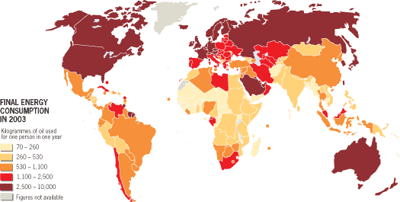
Energy
Describe the global pattern of energy consumption.
________________________________________________________________________________________________________________________________________________________________________________________________________________________________________________________________________________________________________________________________________________________________________________________________________________________________
How might this pattern change in the future?
_______________________________________________________________________________________________________________________________________________________________________________________________________________

The changing demand and provision of resources in the UK create opportunities and challenges
Food in the UK
The UK imports about 40% of the total food consumed. List 4 reasons why it imports so much food below:
- ________________________________________________________________
- ________________________________________________________________
- ________________________________________________________________
- ________________________________________________________________
Many foods travel long distances, known as ‘food miles’. This is very expensive and adds to our carbon footprint (an individual’s use of greenhouse gases). Many vegetables come from Kenya, e.g. mange tout and green beans. The farmers in Kenya receive only 12% of the final price, whereas, supermarkets earn 45% of the price.

What is agribusiness and how will it help to reduce the reliance on foreign imports?
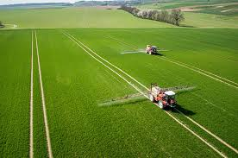
Agribusiness: ______________________________________________________________________________________
Agribusiness helps because ______________________________________________________________________________________________________________________________________________________________________________________________________

What is organic produce?
________________________________________________________________________________
Give 3 advantages of eating local food for people in the UK and the environment.
- ______________________________________________________________________
- ________________________________________________________________
- ________________________________________________________________

Water in the UK
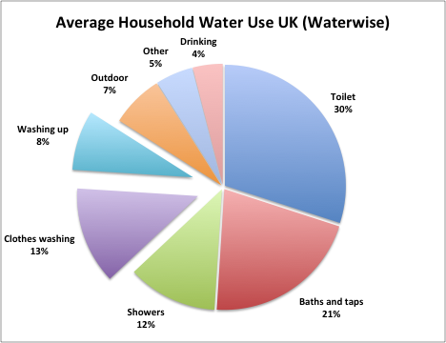
Give 3 reasons for the increased demand for water in the UK:
- _____________________________________________________________
- _____________________________________________________________
- _____________________________________________________________

What is meant by water surplus and water deficit? Give an example of areas in the UK for both:
Water surplus: _________________________________________________________ _____________________________________________________________________
Water deficit: _________________________________________________________ _____________________________________________________________________
Complete the table below to outline how the UK is coping with increased water demand:
Saving water | Water transfer | Managing water quality

Why are some water supplies suffering from pollution?
- ________________________________________________________________
- ________________________________________________________________
- ________________________________________________________________

Energy in the UK
Despite increasing demand for electricity in the UK, energy consumption has actually fallen. Give 2 reasons for this:
- ________________________________________________________________
- ________________________________________________________________
Describe how the UK’s energy mix has changed since 1990.
_________________________________________________________________________________________________________________________________________________________________________________________________________________________________________________________________________________________________________________________________________________________
What is meant by energy security?
_____________________________________________________________________
What is happening to the UK’s supplies of coal, gas and oil?
Coal | Gas | Oil

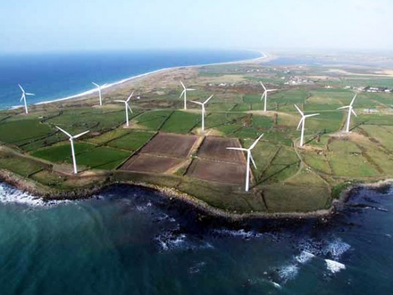
By 2020 the UK aims to meet 15% of its energy requirement from renewable sources. However, it is still heavily reliant on fossil fuels. Why are fossil fuels still so important?
- ___________________________________________________________________
- ___________________________________________________________________
- ___________________________________________________________________
Why is fracking controversial?
__________________________________________________________________________________________________________________________________________

Nuclear energy and wind energy are two important energy sources being developed in the UK. Complete the table below to show the economic and environmental issues associated with exploiting these resources:
 | Economic | Environmental
Nuclear
Wind farms

Demand for food resources is rising globally but supply can be insecure, which may lead to conflict
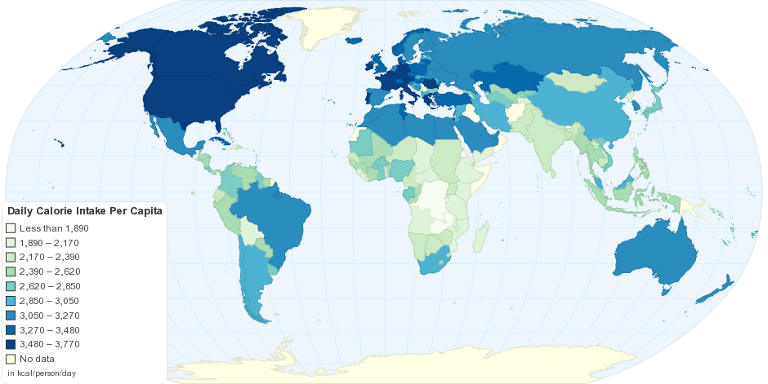
Which continents consume the most food?
____________________________________________________________
Which continent consumes the least food?
________________________________________Why is global food consumption increasing?
- ________________________________________________________________
- ________________________________________________________________
- ________________________________________________________________

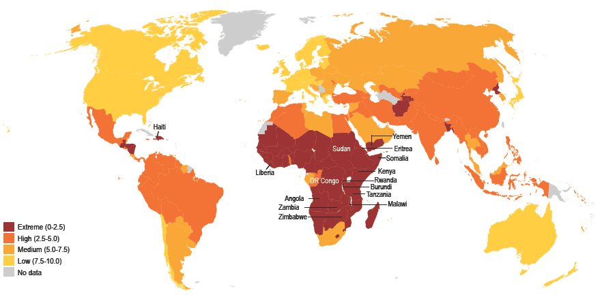
What is the meaning of food surplus?
____________________________________________________________________________________

What is the meaning of food deficit?
__________________________________________________________________________________________________________________________________________
Annotate the photograph below explaining the factors affecting food supply:

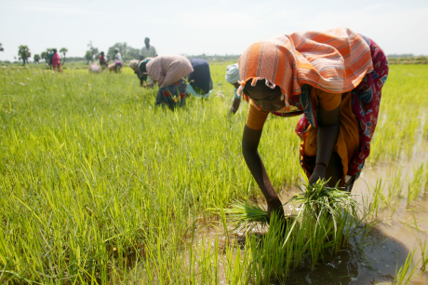

What are the impacts of food insecurity? Complete the table below outlining the effects:
Famine
Under nutrition
Soil erosion
Rising prices
Social unrest
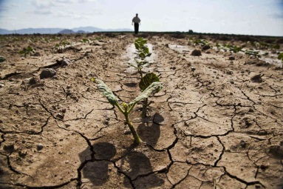
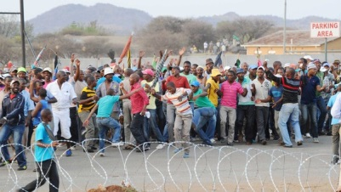
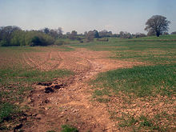
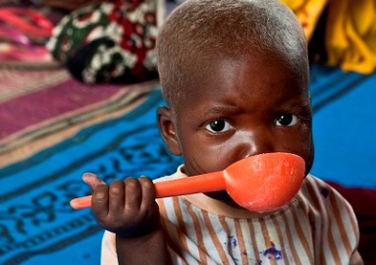

Different strategies can be used to increase food supply
How can we increase the supply of food?
How does irrigation increase the supply of food?
______________________________________________________________________________________________________________________________________________________________________________________________________________________________________________________________________________________________________________________________________________________________________________________________________________________________

Explain below how aeroponics and hydroponics increase the food supply:
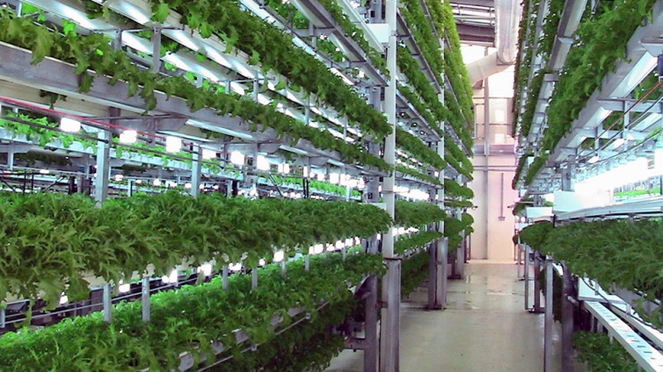
Aeroponics Hydroponics

What is meant by the term ‘green revolution’?
_________________________________________________________________________________________________________________________________________________________________________________________________________________________________________________________________________________________________________________________________________________________
What is biotechnology and how does it increase food yields?
___________________________________________________________________________________________________________________________________________________________________________________________________________________________________________________________________________________________________________________________________________________________________________
How does appropriate technology work to increase food supplies?
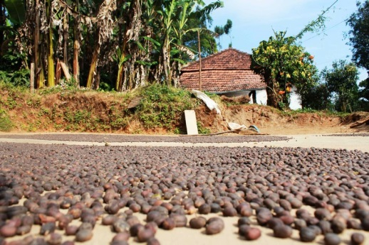
________________________________________________________________________________________________________________________________________________________________________________________________________________________________________________________________________________________________________________________________________________________________________________________________________________________

An example of a large scale agricultural development: Indus Basin Irrigation Scheme: a large scale agricultural development
This area has developed the largest concentration of greenhouses in the world, covering over 26,000 hectares.
Outline below the main features of the project:
______________________________________________________________________________________________________________________________________________________________________________________________________________________________________________________________________________________________________________________________________________________________________________________________________________________________
Complete the table below showing the advantages and disadvantages of IBIS:
Advantages | Disadvantages

What is sustainable food supply?
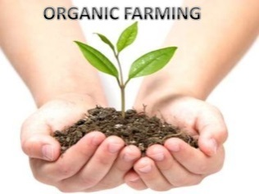
__________________________________________________________________________________________________________________________________________
How can we manage food supplies in a sustainable way?
How is organic farming sustainable?
________________________________________________________________________________________________________________________________________________________________________________________________________________________________________________________________________________________________________________________________________________________________________________________________

Complete the information table below outlining other sustainable methods:
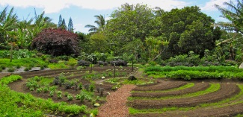  Permaculture | 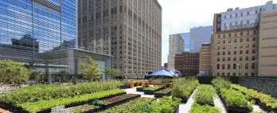  Urban Farming
Fish from sustainable sources | 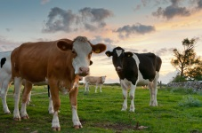  Meat from sustainable sources
Seasonal food consumption | 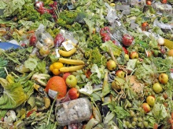  Reducing food loss and waste

An example of a local scheme in a LIC or NEE to increase sustainable supplies of food
Jamalpur district in Bangladesh is an area where over 57 per cent of the income is from agriculture. Many farmers are subsistence farmers who grow food to feed their family. The main crops in the area are rice, jute and wheat.

What does Practical Action Charity in Jamalpur do?
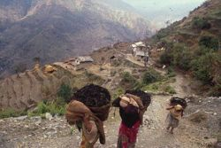
Construction
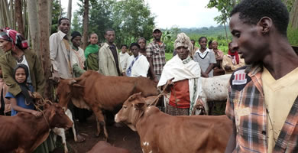
_______________________________________________________________________________________________________________________________________________________________________________

Planting and stocking
_______________________________________________________________________________________________________________________________________________________________________________
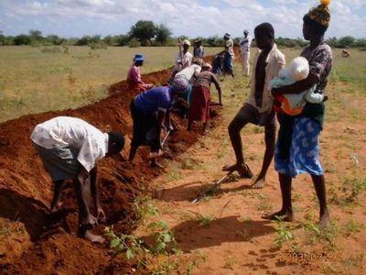
Harvesting
_______________________________________________________________________________________________________________________________________________________________________________

